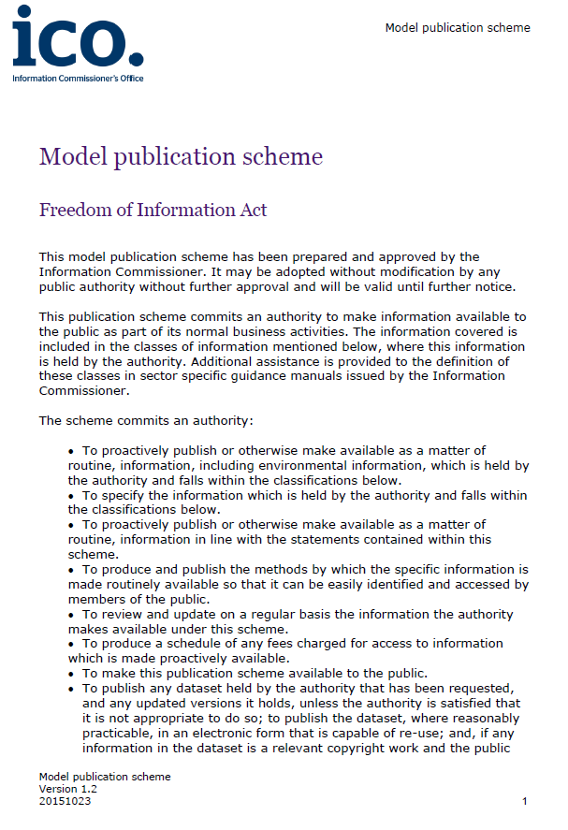

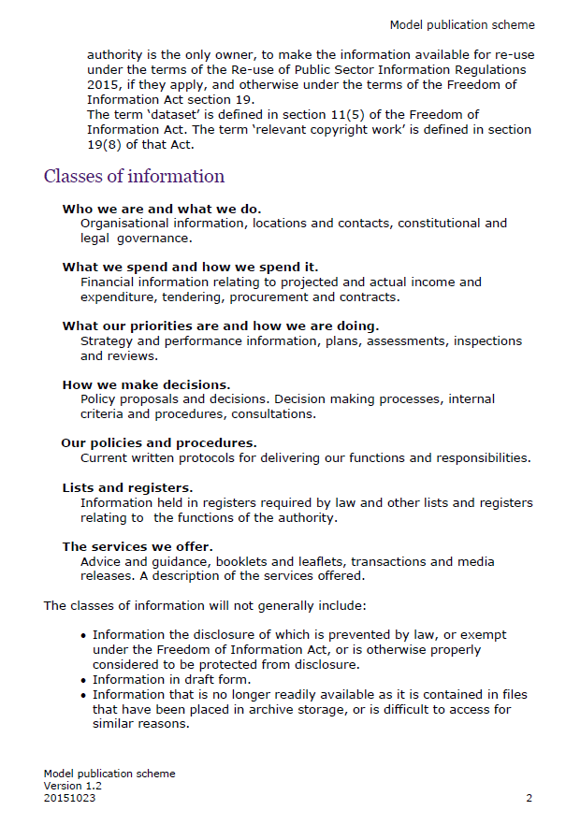

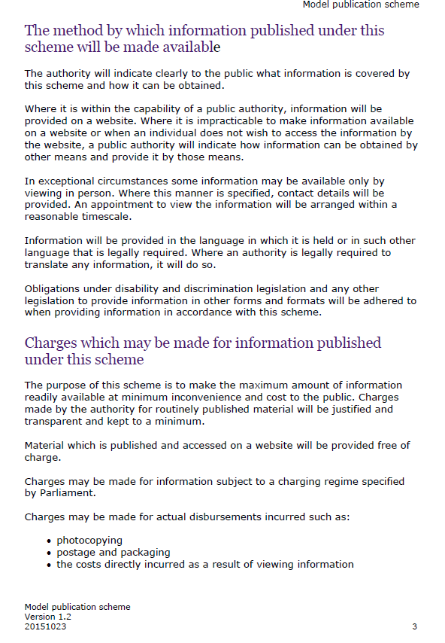

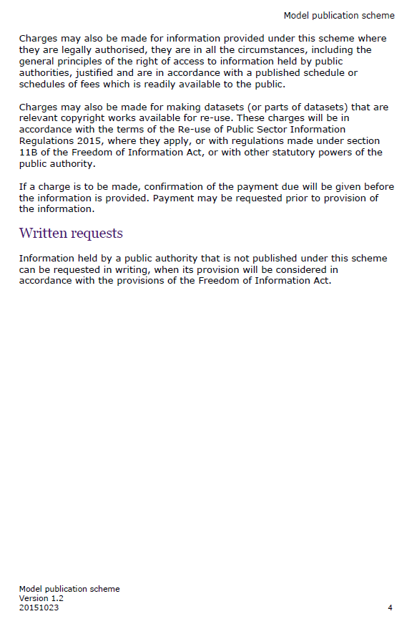

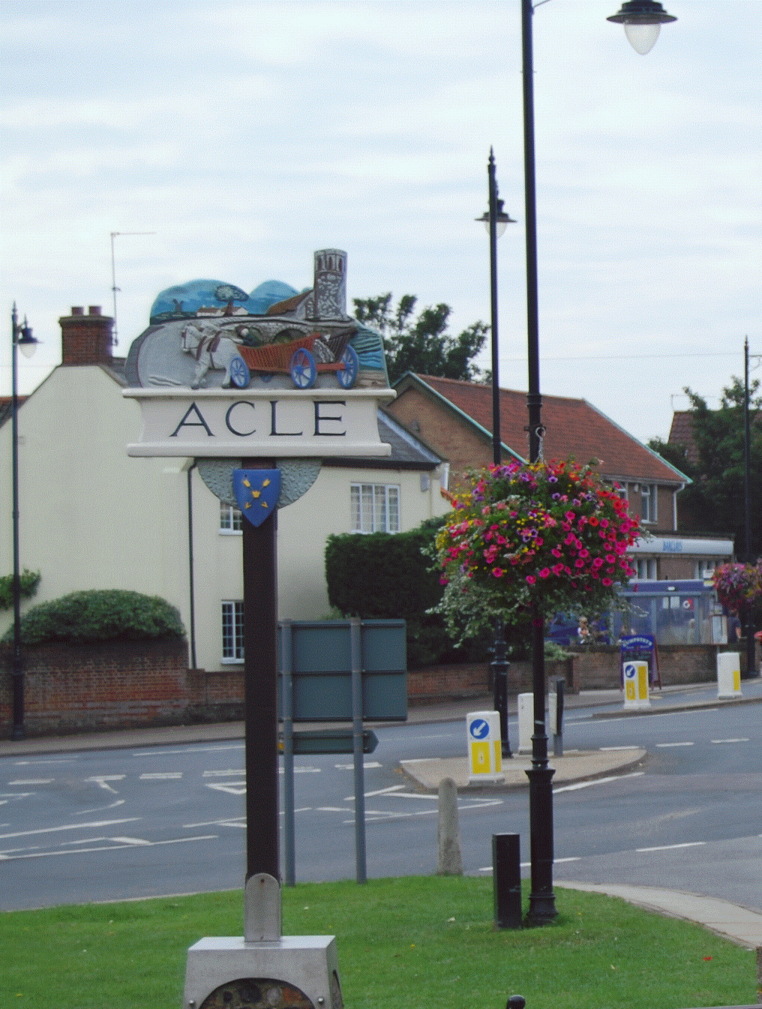

ACLE PARISH COUNCIL

Register of Information - Publication Scheme

Approved and adopted by Acle Parish Council

Information available from Acle Parish Council under their publication scheme
Hard copies and electronic copies of documents are available from the Clerks and will be charged in accordance with the Schedule on Page 12. To request documents please contact the Clerks using the contact details provided on page 11.

Information to be published: | How the information can be obtained:
Class 1 – who we are and what we do
(Organisation information, locations and contracts, constitutional and legal governance)
Current information only

Who’s who on the Council and its Committees | From the Council’s website  Displayed on noticeboards  As a hard copy from the Clerks, or electronically attached to an email from the Clerks
Contact details for Parish Clerk and Councillors (named contacts where possible with telephone number and email address, if used) | From the Council’s website  Displayed on noticeboards  Clerk’s/Deputy’s contact details are on Page 10. Clerk/Deputy and Councillors’ details as a hard copy from the Clerks, as an attachment to an email from the Clerks
Location of main Council office and accessibility details | The Main office is located at:  1st Floor  Brian Grint Centre  The Street  Acle  NR13 3DY  For those with accessibility requirements, there is a downstairs space which can be utilised.  The Clerks do in addition work from home. If a meeting is required this needs to be arranged by appointment, contact details of the Clerks are on page 10.  Monthly council meetings are held at the Methodist Church, meetings are open to the public. Parking is available adjacent to the Church
Staffing structure | Parish Clerk and RFO  Deputy Clerk and Asset Manager  Assistant Clerk and Project Lead  General Operative  Cleaner  Bank Cleaner
Information Class 2 – what we spend and how we spend it
(Financial information relating to projected and actual income and expenditure, tendering, procurement and contracts)
Current and previous financial year as a minimum

Annual Return (Pages 2, 3 and 5)  Reasons for Variations = / - 15%  Payments over £100 [if a council with turnover £25,000 or under] or payments over £500 [if a council with turnover £200,000 or over] | From the Council’s website  As a hard copy from the Clerks, or electronically attached to an email from the Clerks
Finalised budget | From the Council’s website  As a hard copy from the Clerks, or electronically attached to an email from the Clerks
Precept | From the Council’s website  As a hard copy from the Clerks, or electronically attached to an email from the Clerks
Financial Regulations and Standing Orders | From the Council’s website  As a hard copy from the Clerks, or electronically attached to an email from the Clerks
Grants given and received  Grant Award Policy | From the Council’s website  As a hard copy from the Clerks, or electronically attached to an email from the Clerks
List of current contracts awarded and value of the contract for  Street Lights Maintenance | From the Council’s website  As a hard copy from the Clerks, or electronically attached to an email from the Clerks
Councillors’ allowances and expenses | N/A - No allowances or expenses paid.
Class 3 – What our priorities are and how we are doing
(Strategy and performance information, plans, assessments, inspections and reviews)

Action Plan | From the Council’s website  As a hard copy from the Clerks, or electronically attached to an email from the Clerks
Chairman’s Annual Report to Parish Meeting (current year only) | From the Council’s website  As a hard copy from the Clerks, or electronically attached to an email from the Clerks
Minute relating to General Power of Competence adoption | Confirmed at meeting of 22nd May 2023.  From the Council’s website  As a hard copy from the Clerks, or electronically attached to an email from the Clerks
Class 4 – How we make decisions
(Policy proposals and decisions. Decision making process, internal criteria and procedures, consultations)
Current and previous council year as a minimum

Timetable of meetings (Council, any committee/sub-committee meetings and parish meetings) | From the Council’s website  As a hard copy from the Clerks, or electronically attached to an email from the Clerks  Parish noticeboard/s
Agendas of meetings (latest meeting only - as per the timetable of meetings above) | From the Council’s website  As a hard copy from the Clerks, or electronically attached to an email from the Clerks
Minutes of meetings – NB This will exclude information that is properly regarded as private to the meeting (as per the timetable of meetings above) | From the Council’s website  As a hard copy from the Clerks, or electronically attached to an email from the Clerks
Reports presented to council meetings - NB This will exclude information that is properly regarded as private to the meeting (as per the timetable of meetings above) | From the Council’s website  As a hard copy from the Clerks, or electronically attached to an email from the Clerks
Responses to planning applications  Responses to consultation papers | See Minutes  From Broadland District Council’s website or Broads Authority’s website  As a hard copy from the Clerks, or electronically attached to an email from the Clerks
Class 5 – Our policies and procedures
(current written protocols for delivering our functions and responsibilities)
Current information only

Policies | From the Council’s website  As a hard copy from the Clerks, or electronically attached to an email from the Clerks
Policies and procedures for the provision of services and about the employment of staff:  Equality and diversity policy  Lone Workers Policy  Training and Development Policy  Policies and procedures for handling requests for information  Freedom of Information Publication Scheme | From the Council’s website  As a hard copy from the Clerks, or electronically attached to an email from the Clerks
Complaints procedures (including those covering requests for information and operating the publication scheme) | From the Council’s website  As a hard copy from the Clerks, or electronically attached to an email from the Clerks
Class 6 – Lists and registers
(Information held in registers required by law and other lists and registers relating to the functions of the authority)
Current maintained lists and registers only

Any publicly available register or list (if any are held this should be publicised; in most circumstances, existing access provisions will suffice) | From the Council's website.
Assets Register | From the Council’s website – see Accounts  As a hard copy from the Clerks, or electronically attached to an email from the Clerks
Register of members’/councillors’ interests | Available from Broadland District Council website
Register of gifts and hospitality | N/A
Class 7 – The services we offer
(Advice and guidance, booklets and leaflets, transactions and media releases. A description of the services offered.)
Current information only

Burial Grounds | Apply to the Clerks  Fees are available on the Council’s website
Parks and recreational facilities | From the Council’s website or as a hard copy from the Clerks
Seating, litter bins, clocks, memorials and lighting | As a hard copy from the Clerks
Bus Shelters | As a hard copy from the Clerks
Market - occasional summer market only | As a hard copy from the Clerks
Public conveniences | As a hard copy from the Clerks
Agency agreements | From Norfolk County Council for the verge cutting agreement  From Broadland District Council for the management of the public conveniences  Or hard copy from the Clerks
Acle Lands Trust | From the Council’s website or as a hard copy from the Clerks
Acle Food Bank | From the Council’s website or as a hard copy from the Clerks
Allotments | From the Acle Allotment Association website
Acle Recreation Centre | From Acle Recreation Centre directly – note that Acle Parish Council is custodian trustee only and is not responsible for the management of the site
Acle Good Neighbour Scheme | From the Council’s website or as a hard copy from the Clerks
Acle Heating Oil Buying Scheme | From the Council’s website or as a hard copy from the Clerks
Acle’s Businesses List | From the Council’s website or as a hard copy from the Clerks
Beeline for Acle | From the Council’s website or as a hard copy from the Clerks
Acle Youth Club | From the Council’s website or as a hard copy from the Clerks
Acle Men’s Shed | For contact details see the Charity Commission’s website or contact the Charity direct
Acle Tree Warden | From the Council’s website or as a hard copy from the Clerks
How the Council responds to requests
The Council is committed to responding to information requests promptly, fairly, and in accordance with relevant legislation. Upon receiving a request, we assess it to determine if it falls under the scope of the Freedom of Information Act, Environmental Information Regulations, or other applicable laws. We aim to provide a full response within the statutory timeframe, typically 20 working days. Where information can be disclosed, we will provide it in the requested format whenever possible. If we need clarification, require more time due to complexity, or must withhold information under an exemption, we will notify the requester promptly with a clear explanation. Our approach ensures transparency, accountability, and respect for the public’s right to access information.
Vexatious or repeated requests
We are committed to transparency and the responsible handling of information requests. However, under the Freedom of Information Act 2000, we reserve the right to refuse requests that are deemed vexatious. A vexatious request is one that causes a disproportionate or unjustified level of disruption, irritation, or distress without a serious purpose or value. When assessing whether a request is vexatious, we consider factors such as the burden on resources, the motive behind the request, the effect on staff, and any history of previous requests. Each case is evaluated individually to ensure fairness and compliance with legal obligations. We will always provide a clear explanation if a request is refused on these grounds.
Where a request for information has previously been made by an individual the Council is not obliged to comply with a subsequent or substantially similar request from the individual unless a reasonable amount of time has passed between requests.

Maintaining Records of the Request Process:
The Council maintains comprehensive records of all information requests and the corresponding responses to ensure transparency, accountability, and compliance with legal requirements. This includes logging the details of each request, tracking its progress, documenting any correspondence with the requester, and recording the rationale for decisions made, including any exemptions applied. These records are securely stored in line with data protection legislation and retained for an appropriate period as outlined in our records management policy. This systematic approach enables us to monitor performance, support internal reviews or appeals, and demonstrate our commitment to open and accountable governance.
Contact details of the Clerks
Clerk
Mrs Pauline James
Brian Grint Centre
The Street
Acle
NR13 3DY
aclepcclerk@gmail.com
01493 751070

Deputy Clerk
Miss Fiona Richardson
aclepcdeputyclerk@gmail.com
07536 456161

Schedule of charges

This describes how the charges have been arrived at and should be published as part of the guide. (Below is an example of possible charges).

Type of charge | Description | Basis of charge
Disbursement cost | Photocopying @ 20p per single-sided sheet (black & white) | Actual cost based on computer printing
 | Photocopying @ £1.00p per single-sided sheet (colour) | Actual cost based on computer printing
 | Website | Free
 | Postage | Actual cost of Royal Mail standard 2nd class. Recorded delivery if requested at standard price

Date of Policy: 31st March 2025
Review Date: March 2026

Signed:
Chair: Jamie Pizey

Signed:
Deputy Clerk: Fiona Richardson

