Bee Line Beds Acle
Update 20/04/26

The no mowing areas are now 5 years old. They are maturing slowly into a diversified grass/flower beds. The areas are New Close, South Walsham road, England’s Road and Damgate lane Play Area
In October 2024 lines were turf stripped and re seeded. They have faired differently in each of the areas, the best being new close opposite the fih and chip shop. This are seeded well and now has a strip of corncockle, corn flower, ox eyed daisy, red clover, white clover, musk mallow teasel kidney vetch, wild marjoram with other species. This has been so successful that we are considering turf stripping a larger area this autumn with luck to create a bigger display. Wild Fennel daffodil, foxglove and cow parsley have come up with the no mow policy, so the area is naturalising. The soils here are less nutrient rich.
The area at England’s Road is also developing after the turf stripping but species diversity is less. This is due to a richer soil but also disturbance by BT and digging up part of the area in 2025.
South Walsham Road was not turf stripped as an experiment to see what happens if you just stop mowing. Ther is a varying species list including comfrey and red clover milk parsley as well as a change in grass mix, this area, as do all areas, suffer as we don’t cut and collect due to the contractor not having any equipment to do so, so the nutrient level remains high but the species mix is naturalising it would benefit from areas reseeding to give wild flowers a boost and definitely benefit from a yellow rattle introduction. This are suffers the most disturbance as you would imaging from young people walking over it on the way to school, dogs and a person who feel the need to cut a strip with his mower
Damgate lane Play area again is slowly changing and would benefit from a bigger area of turf stripping and re seeding. The area is heavily used as you would accept being a play area but is respected mostly and is maturing.
As money becomes available, we would like to undertake bigger tirf stripping but also find or acquire cut and removal machinery to de nutrify and manage better going forward
The Beeline group would also like to do some PR work and maybe a workshop re rewilding your garden, to enable local people to have wild patches . A lot of gardeners do this it would be great to be able to record this in a year’s citizen science to see what Acle has to offer in its garden maybe in 2027

Beeline 04/26

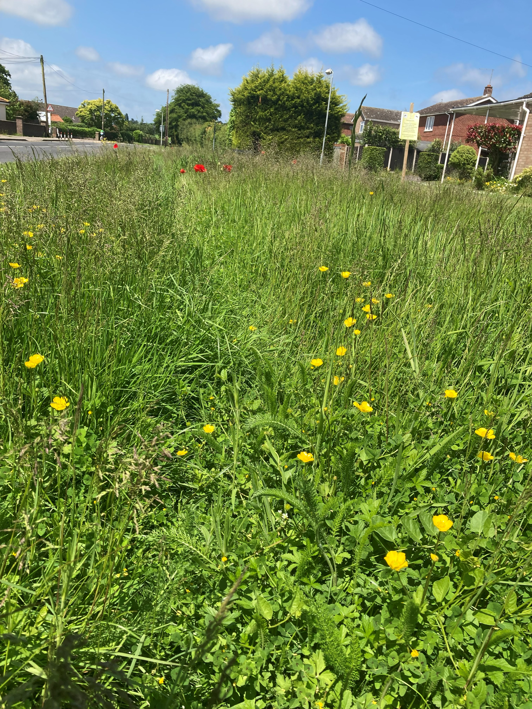 | 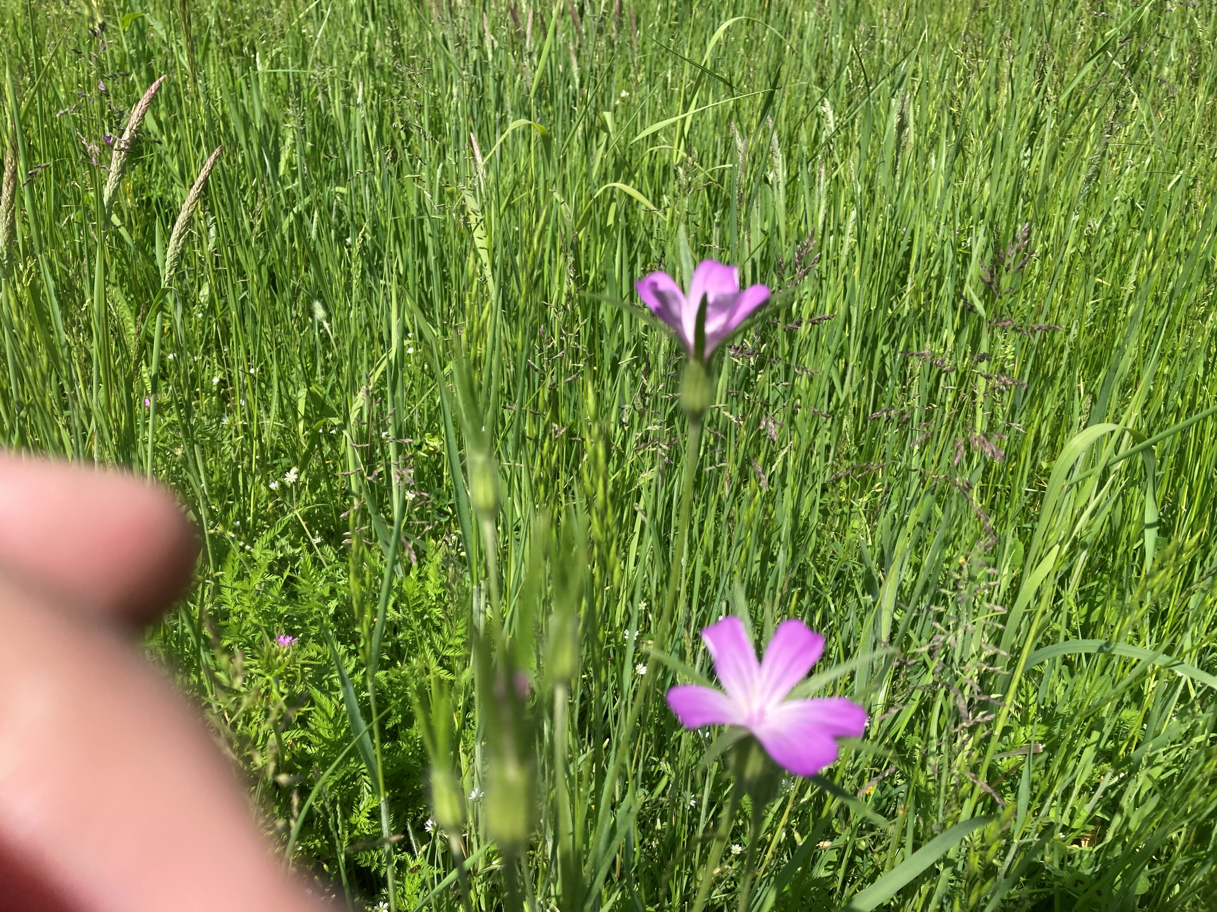
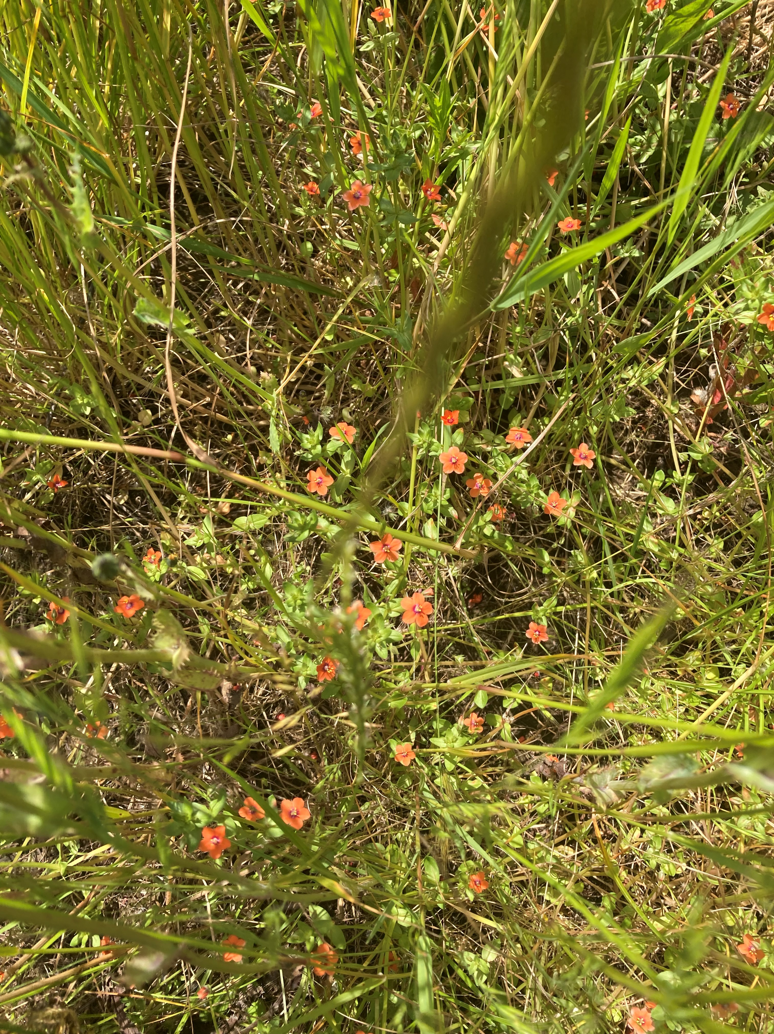 | 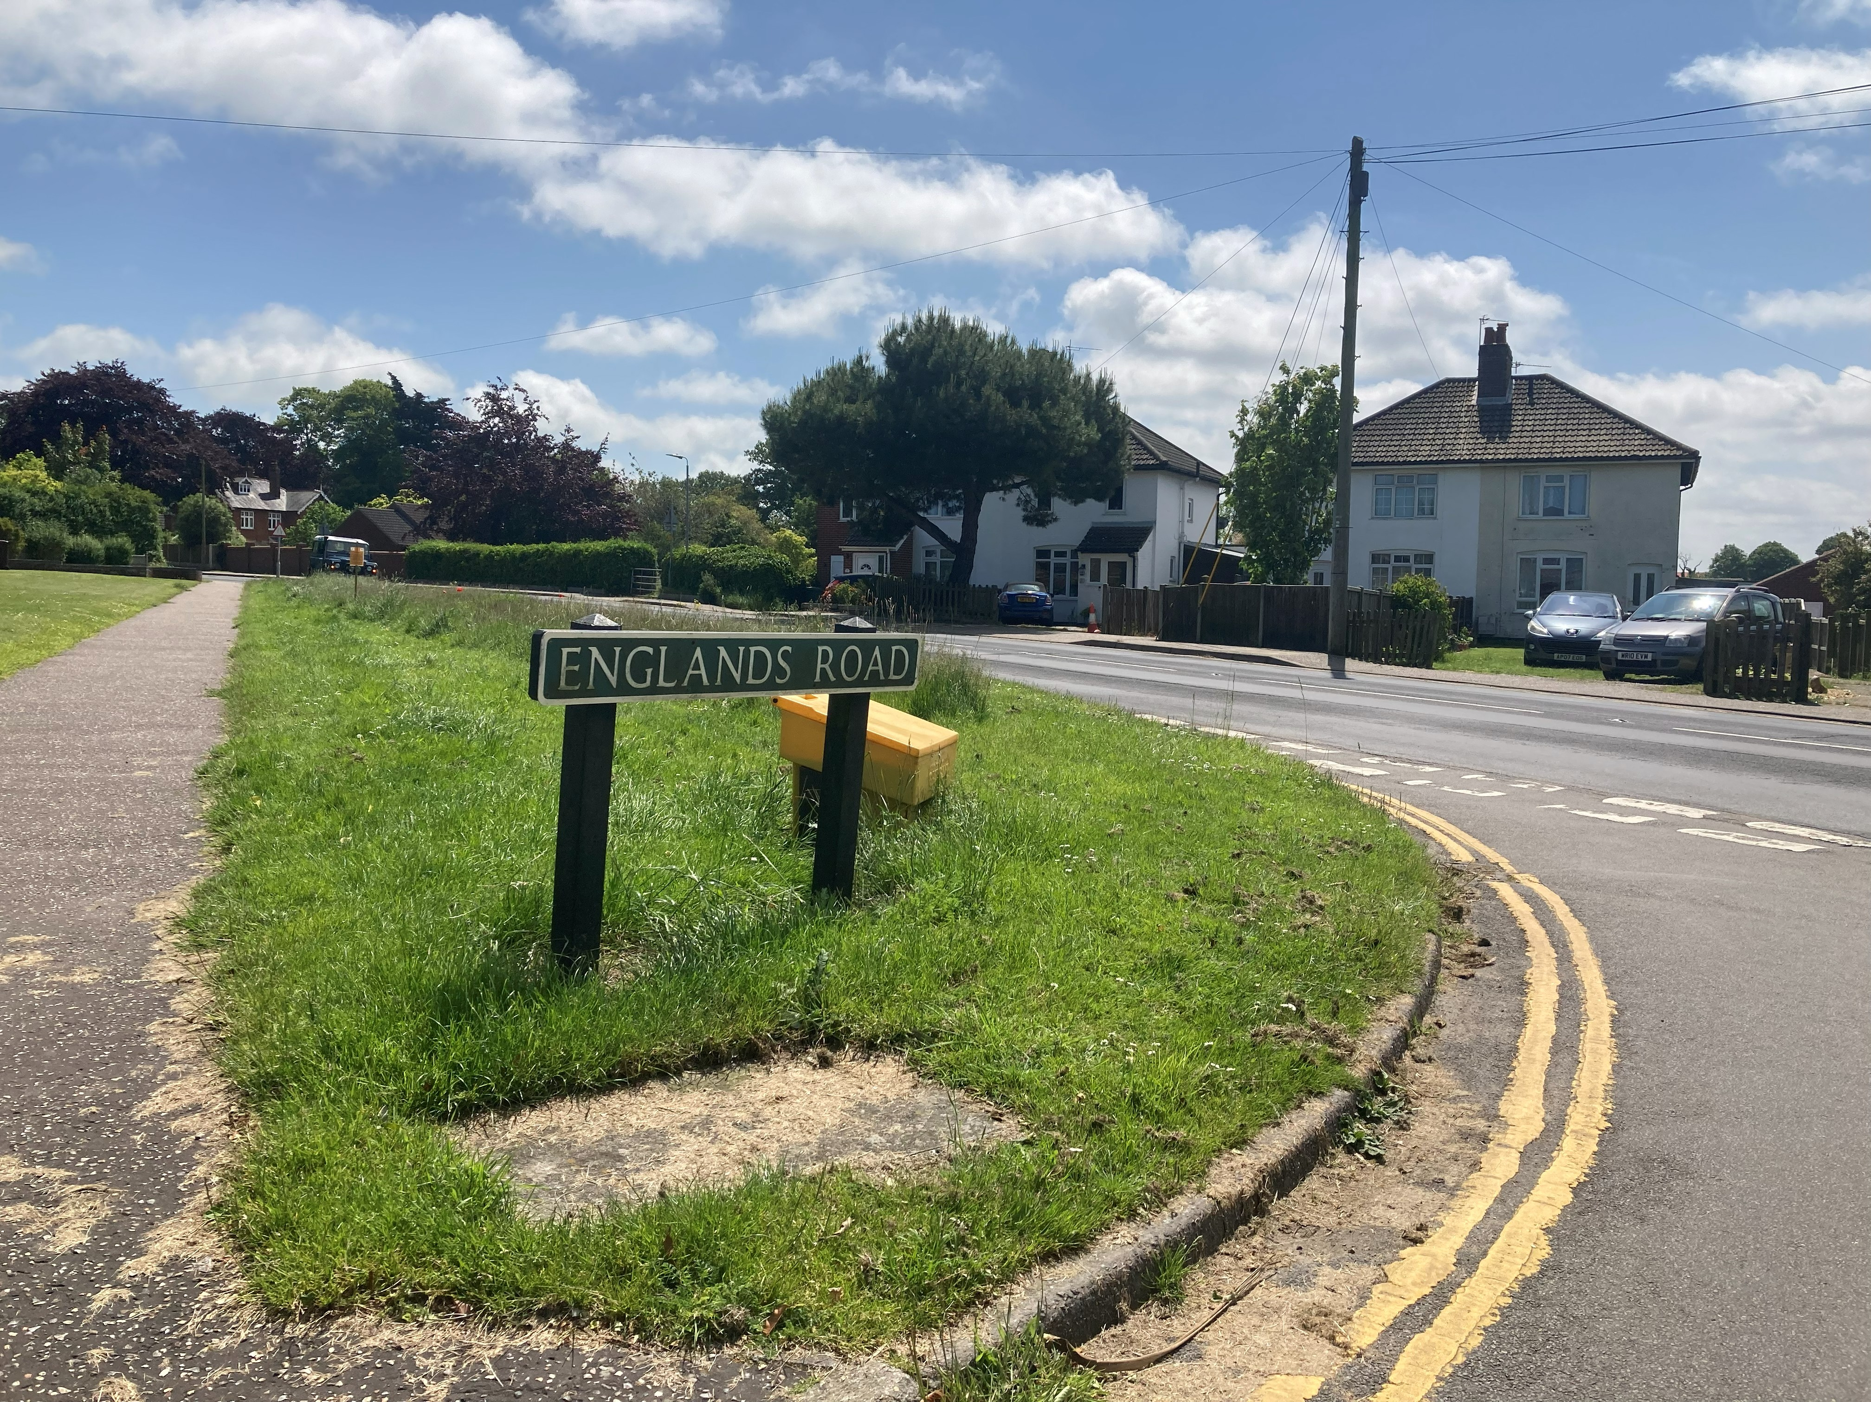
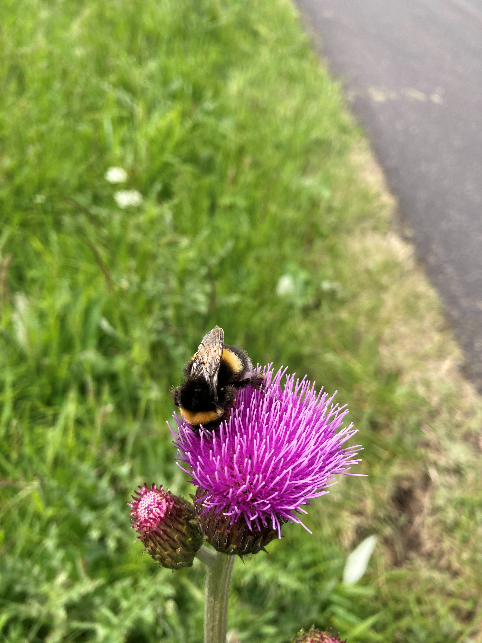 | 